PROJECT FILE
ON
Smart Attendance Management System using
Computer Vision
Submitted by:
Shatrughan Yadav
Roll No:2208252016
Supervisor :
Dr. Shan-E-Fatima

B. TECH CSE(AI&DS)
FACULTY OF ENGINEERING AND TECHNOLOGY
KHWAJA MOINUDDIN CHISHTI LANGUAGE UNIVERSITY
LUCKNOW
(2026)

DECLARATION
I hereby declare that the project titled “Smart Attendance Management System using Computer Vision” submitted by me is an original work carried out under the guidance and supervision of my mentor. This project has not been submitted previously, either in part or in full, for the award of any degree, diploma, or any other academic qualification in this or any other institution.
I further declare that all the information, data, and references used in this project have been properly acknowledged and cited wherever necessary. I have adhered to the ethical standards and guidelines required for academic work.
I take full responsibility for the authenticity, accuracy, and originality of the work presented in this report. I also confirm that this project is the result of my own efforts and learning during the course of study.
I understand that any violation of academic integrity may lead to disciplinary action as per the rules of the institution.
Name of Student: Shatrughan Yadav
Roll Number: 2208252016
Course: B. Tech
Subject: CSE with AI & DS
Institution Name: K.M.C. Language University, Lucknow, Uttar Pradesh
Signature: ____________________
Date: ____________________

CERTIFICATE
This is to certify that the project titled “Smart Attendance Management System using Computer Vision” is a Bonafide record of the work carried out by Shatrughan Yadav, bearing Roll Number 2208252016, a student of Bachelor of Technology (B. Tech) in CSE with AI & DS, submitted in partial fulfillment of the requirements for the award of the degree of Bachelor of Technology during the academic year 2025–2026.
The project work has been carried out under my supervision and guidance. During the course of this project, the student has demonstrated a high level of dedication, technical understanding, and problem-solving ability in the field of computer vision and artificial intelligence.
To the best of my knowledge, this work is original and has not been submitted elsewhere for the award of any other degree or diploma. The project meets the academic standards and requirements prescribed by the institution.
I wish the student success in all future academic and professional endeavors.

Project Guide: ____________________
(Signature)

ACKNOWLEDGEMENT
I would like to express my sincere gratitude to my project guide Dr. Shan-E-Fatima for their invaluable guidance, continuous support, and constructive suggestions throughout the development of this project titled “Smart Attendance Management System using Computer Vision.” Their encouragement and insightful feedback played a crucial role in the successful completion of this work.
I am also highly thankful to the Head of the Department and faculty members of Department of Computer Science & Engineering, K.M.C. Language University, Lucknow, Uttar Pradesh for providing the necessary infrastructure, resources, and academic support required to carry out this project efficiently. Their cooperation and guidance helped me overcome various challenges during the project development.
I would like to extend my appreciation to my classmates and friends for their helpful discussions, suggestions, and moral support, which greatly contributed to improving the quality of this project.
I am deeply grateful to my family for their constant encouragement, patience, and unwavering support throughout my academic journey. Their motivation has always been a source of strength for me.
Finally, I would like to thank everyone who directly or indirectly contributed to the successful completion of this project. This project has been a great learning experience and has enhanced my technical skills, problem-solving ability, and understanding of real-world applications of computer vision and artificial intelligence.
Name of Student: Shatrughan Yadav
Signature: ____________________

ABSTRACT
The project titled “Smart Attendance Management System using Computer Vision” is designed to automate the process of attendance marking by utilizing advanced image processing and machine learning techniques. Traditional attendance systems are often time-consuming, prone to human error, and allow proxy attendance. This project aims to overcome these limitations by introducing a smart and efficient automated solution.
The system captures real-time video input through a camera, detects human faces, and recognizes individuals using trained models. Face detection is implemented using the Haar Cascade algorithm, while face recognition is performed using the ArcFace deep face recognition model through the InsightFace framework with ONNX Runtime for improved accuracy and reliability.
Once a face is recognized, the system automatically marks attendance and stores the data in a structured database with details such as name, date, and time. This ensures reliable record-keeping and easy retrieval of attendance information.
The proposed system enhances accuracy, minimizes manual effort, prevents fraudulent attendance, and saves time. It is highly useful for educational institutions, offices, and organizations where efficient attendance tracking is required.
Overall, this project demonstrates the practical application of computer vision and artificial intelligence in solving real-world problems, making attendance management more secure, reliable, and efficient.
In the updated version, the system has been extended into a web-based Smart Attendance Management System with a cleaner frontend dashboard, admin login, student registration, guided face capture, automatic model training, and attendance verification through a camera interface. The system now maintains a unique numeric ID for every student while allowing duplicate names, which improves data consistency and avoids incorrect mapping during recognition.
The attendance module also supports daily tracking, prevents duplicate attendance for the same student on the same date, and displays the student attendance percentage after successful verification. During registration, the interface guides the student to look straight, left, right, up, and down so that the trained model receives more reliable face samples.

Section | Title | Page No.
Chapter 1: | Introduction | 10-16
 | 1.1 Background of the Study | 11-12
 | 1.2 Problem Statement | 12-13
 | 1.3 Objectives | 13
 | 1.4 Scope of the Study | 13-14
 | 1.5 Motivation | 14-15
 | 1.6 Overview of Proposed System | 15-16
 | 1.7 Organization of the Report | 16
Chapter 2: | Literature Review | 17-22
 | 2.1 Existing Systems | 19-20
 | 2.2 Limitations of Existing Systems | 20-21
 | 2.3 Proposed System | 21-22
 | 2.4 Comparative Analysis | 22
Chapter 3: | Methodology | 23-29
 | 3.1 Data Collection | 23
 | 3.2 Face Detection | 23-24
 | 3.3 Face Recognition | 24-25
 | 3.4 Model Training | 25-26
INDEX

 | 3.5 Attendance Marking | 26-27
 | 3.6 System Workflow | 27-28
 | 3.7 Advantages of Methodology | 28
 | 3.8 Limitations of Methodology | 28-29
 | 3.9 Summary | 29
Chapter 4: | System Design | 30-41
 | 4.1 System Architecture | 30-31
 | 4.2 Data Flow | 31-32
 | 4.3 System Modules | 32-36
 | 4.3.1 Registration Module | 33
 | 4.3.2 Training Module | 33-35
 | 4.3.3 Recognition Module | 35
 | 4.3.4 Attendance Module | 36
 | 4.4 Flowchart | 36
 | 4.5 Database Design | 36-37
 | 4.6 System Requirements | 38-39
 | 4.6.1 Hardware Requirements | 38
 | 4.6.2 Software Requirements | 38-39
 | 4.7 Algorithms Used | 39-40
 | 4.8 Advantages of Algorithm | 40
 | 4.9 Limitations of Algorithm | 40
 | 4.10 System Design Considerations | 40
 | 4.11 Advantages of System Design | 41
 | 4.12 Summary | 41
Chapter 5: | Implementation | 42-48
 | 5.1 Tools and Technologies Used | 42-43
 | 5.2 Key Modules Implementation | 43-45
 | 5.2.1 Image Capture Module | 43-44
 | 5.2.2 Face Detection Module | 44
 | 5.2.3 Face Recognition Module | 44-45
 | 5.2.4 Attendance Module | 45
 | 5.3 System Integration | 45-46
 | 5.4 Output | 46
 | 5.5 Advantages of Implementation | 47
 | 5.6 Challenges Faced | 47
 | 5.7 Testing and Validation | 47
 | 5.8 Summary | 48
Chapter 6: | Results and Discussion | 49-53
 | 6.1 Results | 49-50
 | 6.2 Performance Analysis | 50-51
 | 6.3 Discussion | 51-52
 | 6.4 Comparative Analysis | 52
 | 6.5 Practical Applications | 53
 | 6.6 Future Improvements | 53
 | 6.7 Summary | 53
Chapter 7: | Conclusion and Future Scope | 54-56
 | 7.1 Conclusion | 54-55
 | 7.2 Future Scope | 55-56
 | Final Sections | 57-59
 | References | 57
 | Appendix | 58-59

Chapter 1
Introduction
Today’s digital era, automation has become an essential part of various sectors, including education, business, and administration. With the rapid In advancement of technology, organizations are continuously seeking efficient and reliable methods to manage daily operations. One such important task is attendance management, which plays a crucial role in maintaining discipline, tracking performance, and ensuring accountability. However, traditional attendance systems, such as manual registers and ID-based methods, are often time-consuming, inefficient, and prone to errors.
Manual attendance systems require significant effort from both instructors and students. These systems are vulnerable to issues such as incorrect entries, data manipulation, and proxy attendance, where one individual marks attendance on behalf of another. Similarly, ID card-based systems, although slightly more advanced, still face challenges such as card loss, misuse, and dependency on physical interaction. These limitations highlight the need for a more secure, automated, and intelligent solution.
With the emergence of modern technologies such as computer vision and machine learning, it has become possible to design smart systems that can automate complex tasks with high accuracy. Computer vision enables machines to interpret and understand visual data, while machine learning allows systems to learn from data and improve their performance over time. By combining these technologies, an advanced attendance system can be developed that minimizes human intervention and enhances reliability.
The project titled “Smart Attendance Management System using Computer Vision” aims to address the shortcomings of traditional attendance methods by introducing an automated, contactless, and intelligent system. This system uses a camera to capture real-time images or video streams, detects human faces, and recognizes individuals using trained machine learning models. Once a person is identified, their attendance is automatically recorded in a database along with relevant details such as date and time.
The face detection process is typically carried out using algorithms such as Haar Cascade, which efficiently identifies facial features within an image. For face recognition, modern deep-learning techniques such as ArcFace embeddings are employed to accurately match detected faces with stored data. These technologies ensure that the system performs efficiently even under varying lighting conditions and moderate facial pose changes.
One of the key advantages of this system is that it eliminates the need for manual intervention, thereby reducing errors and saving time. It also prevents fraudulent practices like proxy attendance, as the system verifies the identity of each individual based on unique facial features. Additionally, the automated storage of attendance records in a digital database makes data management more organized, secure, and easily accessible.
Furthermore, the system is designed to be user-friendly and scalable, making it suitable for a wide range of applications, including educational institutions, corporate offices, and other organizations. It provides a contactless solution, which is especially beneficial in maintaining hygiene and safety in environments where physical interaction should be minimized.
This project not only improves efficiency but also enhances transparency and accountability in attendance management. It demonstrates the practical implementation of artificial intelligence and computer vision in solving real-world problems. The system can also be further enhanced by integrating advanced technologies such as cloud storage, real-time analytics, and mobile applications for remote monitoring.
In conclusion, the Smart Attendance Management System using Computer Vision represents a significant step towards digital transformation in attendance tracking. By leveraging modern technologies, it offers a reliable, accurate, and efficient alternative to traditional methods, ultimately improving productivity and operational effectiveness.
1.1 Background of the Study
Attendance tracking is a fundamental activity in educational institutions, corporate organizations, and various workplaces. It plays a crucial role in monitoring performance, maintaining discipline, and ensuring accountability among individuals. Traditionally, attendance has been recorded using manual methods such as paper registers or attendance sheets. While these methods are simple and widely used, they suffer from several limitations.
Manual attendance systems are time-consuming and require significant human effort. In large classrooms or organizations, marking attendance individually can take a considerable amount of time, thereby reducing productivity. Additionally, these systems are highly prone to human errors such as incorrect entries, missing data, or duplication. One of the most common issues associated with traditional methods is proxy attendance, where one person marks attendance on behalf of another, leading to inaccurate records.
With technological advancements, alternative methods such as RFID cards, biometric systems, and ID-based tracking have been introduced. Although these methods provide some level of automation, they still have drawbacks such as dependency on physical devices, chances of misuse, and higher implementation costs.
In recent years, the emergence of computer vision and artificial intelligence (AI) has opened new possibilities for automation. Computer vision enables machines to interpret visual information, while AI allows systems to learn and make decisions based on data. These technologies can be combined to develop intelligent systems capable of identifying individuals through facial recognition.
This project utilizes these advanced technologies to create a smarter, faster, and more reliable attendance system. By automating attendance through facial recognition, the system eliminates manual effort and significantly improves accuracy and efficiency.
1.2 Problem Statement
Traditional attendance systems face multiple challenges that limit their effectiveness in modern environments. Manual methods are not only time-consuming but also inefficient when dealing with large groups of people. They require continuous human involvement, which increases the chances of errors and inconsistencies.
Another major issue is the lack of security in traditional systems. Proxy attendance is a common problem where individuals mark attendance for absent peers. This compromises the authenticity of attendance records and affects overall system reliability.
Existing automated systems, such as RFID or fingerprint-based solutions, also have limitations. RFID cards can be lost or misused, and biometric systems may require physical contact, which is not always desirable in situations requiring hygiene and safety.
Therefore, there is a clear need for an advanced system that is:
- Automated and efficient
- Accurate and reliable
- Secure against fraudulent practices
- Contactless and user-friendly
This project aims to address these issues by developing a computer vision-based attendance system that provides a modern solution to traditional problems.
1.3 Objectives
The main objectives of this project are:
- To develop an automated attendance system using computer vision and machine learning techniques.
- To detect and recognize human faces in real-time using a camera.
- To eliminate proxy attendance and reduce manual errors.
- To store attendance data efficiently in a structured database.
- To provide a fast, accurate, and contactless solution for attendance management.
- To improve overall efficiency and reduce time consumption in attendance tracking.
- To create a scalable system that can be adapted for various environments.
These objectives collectively aim to build a reliable and intelligent attendance system suitable for modern needs.
Additional objectives of the updated system include:
To ensure that every student is identified by a unique student ID even when two or more students have the same name.
To provide an admin-controlled dashboard for student registration, model training, student records, and attendance reports.
To prevent duplicate attendance marking for the same student on the same day.
To calculate and display daily attendance percentage for each registered student.
To provide a one-click launcher and web interface so that the system can be operated without repeatedly running the project manually from the code editor.
1.4 Scope of the Study
The scope of this project is focused on developing a facial recognition-based attendance system that can be used in educational institutions and organizations. The system is designed to operate in real-time using a camera to capture images and identify individuals.
This project can be applied in:
- Classrooms for student attendance
- Offices for employee monitoring
- Training centers and workshops
- Small to medium-sized organizations
The system primarily focuses on:
- Face detection using image processing techniques
- Face recognition using trained models
- Automatic attendance marking and storage
However, the project does not include:
- Large-scale cloud deployment
- Multi-location synchronization
- Advanced security layers like multi-factor authentication
- Integration with enterprise-level systems
Despite these limitations, the system provides a strong foundation that can be further enhanced in the future.
1.5 Motivation
The motivation behind this project arises from the need to overcome the drawbacks of traditional attendance systems. Manual methods are inefficient, time-consuming, and prone to errors, making them unsuitable for modern fast-paced environments.
With the rapid growth of artificial intelligence and computer vision, there is an opportunity to design smarter systems that can automate routine tasks. Facial recognition technology, in particular, offers a unique advantage as it identifies individuals based on their natural features, eliminating the need for physical devices.
The key motivating factors include:
- Reducing manual workload
- Eliminating proxy attendance
- Improving accuracy and reliability
- Enhancing security and transparency
- Utilizing modern technologies for real-world applications
This project is also motivated by the desire to apply theoretical knowledge of AI and computer vision in a practical and impactful way.
1.6 Overview of Proposed System
The proposed system is a Smart Attendance Management System using Computer Vision that automates attendance marking through facial recognition.
The working of the system can be summarized as follows:
- A camera captures real-time images or video.
- The system detects faces present in the frame.
- Detected faces are compared with stored data.
- If a match is found, the individual is recognized.
- Attendance is automatically recorded in a database with date and time.
The system uses:
- Face detection algorithms (e.g., Haar Cascade)
- Face recognition techniques (e.g., ArcFace deep embeddings or other modern deep learning models)
- A database for storing attendance records

Key features of the system include:
Unique student ID validation for reliable student mapping
Admin-only access for registration, training, and report viewing
Daily Excel-based attendance records with date and time
Automatic duplicate attendance prevention for the same day
Student-wise attendance percentage calculation
Simple frontend interface for attendance, login, registration, training, and reports
- Real-time processing
- High accuracy
- Contactless operation
- Automated data storage
- Easy accessibility of records
This system reduces dependency on manual processes and enhances overall efficiency.
1.7 Organization of the Report
This report is structured into seven chapters, each focusing on a specific aspect of the project:
- Chapter 1: Introduction
Provides background information, problem statement, objectives, scope, motivation, and system overview.
- Chapter 2: Literature Review
Discusses existing attendance systems, related research, and technological advancements.
- Chapter 3: Methodology
Explains the design, algorithms, and working process of the proposed system.
- Chapter 4: System Design
Includes architecture diagrams, flowcharts, and system components.
- Chapter 5: Implementation
Describes tools, technologies, and code-level explanations.
- Chapter 6: Results and Discussion
Presents system outputs, performance analysis, and observations.
- Chapter 7: Conclusion and Future Scope
Summarizes the project and suggests improvements and future enhancements.
This structured approach ensures a clear understanding of the project from concept to implementation and evaluation.

Chapter 2:
Literature Review
The development of automated attendance systems has gained significant attention with the rapid growth of computer vision and artificial intelligence (AI). Traditional attendance methods, such as manual registers and ID-based systems, have been widely used for many years. However, these methods are inefficient, time-consuming, and prone to human errors. They also fail to prevent fraudulent practices such as proxy attendance, which reduces the reliability of attendance records.
To overcome these limitations, researchers have explored various automated approaches. Early systems focused on biometric technologies such as fingerprint recognition and Radio Frequency Identification (RFID). Fingerprint-based systems improved accuracy by using unique biological features for identification. Similarly, RFID systems enabled automatic attendance marking through card scanning. Although these methods provided better accuracy compared to manual systems, they required physical contact or additional hardware, which increased implementation costs and reduced convenience.
Fingerprint systems also faced challenges such as sensor wear, hygiene concerns, and difficulty in recognizing fingerprints under certain conditions. RFID systems, on the other hand, were susceptible to misuse, as cards could be shared or lost. These drawbacks highlighted the need for a more secure, contactless, and efficient solution.
With advancements in image processing and machine learning, face recognition technology emerged as a promising alternative. Face recognition systems use visual data captured through cameras to identify individuals based on their facial features. One of the most commonly used techniques for face detection is the Haar Cascade algorithm, which efficiently detects faces in real-time by analyzing patterns in images.
For face recognition, algorithms such as Local Binary Pattern Histogram (LBPH) and Eigenfaces have been widely used. The LBPH method is particularly popular due to its simplicity, speed, and ability to perform well under varying lighting conditions. Eigenfaces, based on principal component analysis (PCA), reduce the dimensionality of facial data and help in identifying unique facial patterns. These techniques laid the foundation for many early face recognition-based attendance systems.
In recent years, the field has seen significant advancements with the introduction of deep learning techniques. Convolutional Neural Networks (CNNs) have revolutionized face recognition by providing higher accuracy and robustness. CNN-based models can automatically extract complex features from images and handle variations in lighting, facial expressions, and angles more effectively than traditional methods. These models are widely used in modern applications such as security systems, smartphone authentication, and surveillance.
Despite these advancements, several challenges still exist in the implementation of face recognition-based attendance systems. Handling large crowds efficiently remains a difficult task, as processing multiple faces simultaneously can affect system performance. Variations in lighting conditions, occlusions (such as masks or glasses), and changes in appearance can also impact accuracy. Additionally, concerns related to data privacy and security must be addressed to ensure that personal information is protected.
Another important aspect is system speed and real-time performance. While advanced models provide high accuracy, they often require significant computational resources, which may not be suitable for all environments. Therefore, a balance between accuracy, speed, and cost must be maintained when designing such systems.
The proposed project, titled “Smart Attendance Management System using Computer Vision,” aims to build upon these existing technologies to develop an efficient and reliable solution. The system integrates face detection and recognition techniques to automate attendance marking in a contactless manner. By using optimized algorithms and real-time processing, the system ensures accuracy while maintaining speed and usability.
In conclusion, the literature review highlights the evolution of attendance systems from manual methods to advanced AI-based solutions. While significant progress has been made, there is still scope for improvement in terms of scalability, performance, and security. The proposed system addresses these challenges by providing a practical and effective attendance management solution using computer vision technologies.

2.1 Existing Systems
Attendance management has evolved significantly over time, transitioning from manual methods to advanced automated systems. In educational institutions and organizations, various attendance tracking systems are currently in use, each with its own advantages and limitations.
The most basic and widely used method is the manual attendance system, where attendance is recorded using paper registers. This method is simple and does not require any technical infrastructure. However, it is highly inefficient, especially in large classrooms or organizations, as it consumes valuable time. Manual systems are also prone to human errors such as incorrect entries, duplication, and omission of data. Moreover, they are highly vulnerable to proxy attendance, which compromises the authenticity of records.
To overcome some of these limitations, biometric systems were introduced. Among these, fingerprint-based attendance systems became widely popular due to their ability to uniquely identify individuals based on biological characteristics. These systems improved accuracy and reduced proxy attendance. However, they require physical contact with the device, which raises hygiene concerns, especially in situations where multiple users interact with the same sensor. Additionally, fingerprint systems may fail due to issues such as dirty sensors, worn-out fingerprints, or improper finger placement.
Another commonly used system is the RFID-based attendance system, which utilizes ID cards embedded with radio frequency tags. In this method, users scan their cards to mark attendance. RFID systems are faster than manual methods and reduce the chances of human error. However, they still rely on external devices and can be misused if cards are shared or lost. This reduces the reliability and security of the system.
In recent years, advancements in computer vision and artificial intelligence have led to the development of face recognition-based attendance systems. These systems use cameras to capture images or video streams and automatically detect and recognize individuals based on their facial features. Unlike biometric or RFID systems, face recognition is completely contactless and does not require any physical interaction.
Face recognition systems typically use algorithms such as Haar Cascade for face detection and methods like Local Binary Pattern Histogram (LBPH), Eigenfaces, or deep learning models for recognition. These systems provide higher efficiency, improved accuracy, and better user convenience. They are also scalable and can be integrated with existing digital infrastructure.
Overall, the evolution of attendance systems reflects the growing need for automation, efficiency, and security. While traditional and earlier automated systems have contributed significantly, modern face recognition systems represent a major advancement in attendance management.
2.2 Limitations
Despite continuous improvements in attendance management systems, several limitations still exist across different approaches. These challenges affect the overall performance, reliability, and usability of such systems.
One of the primary limitations is associated with manual attendance systems. These systems are highly time-consuming and require significant human effort. In large classrooms or organizations, marking attendance manually can take a considerable amount of time, reducing productivity. Furthermore, manual systems are prone to errors such as incorrect entries, missed records, and data manipulation. Proxy attendance remains a major concern, as there is no mechanism to verify the authenticity of the individual marking attendance.
Fingerprint-based biometric systems, although more secure than manual methods, also have their drawbacks. These systems require physical contact, which can lead to hygiene issues, especially in environments where many users interact with the same device. Additionally, fingerprint sensors may not always function properly due to dirt, moisture, or wear and tear. In some cases, individuals with damaged or unclear fingerprints may face difficulty in authentication.
Similarly, RFID-based systems have limitations related to security and dependency on physical devices. Since RFID cards can be easily shared, lost, or duplicated, the system becomes vulnerable to misuse. This compromises the integrity of attendance records. Moreover, the requirement of additional hardware increases the overall cost and maintenance effort.
Even face recognition systems, despite being advanced, are not free from challenges. These systems may face difficulties under varying lighting conditions, changes in facial appearance, or different angles and poses. For example, poor lighting or shadows can affect the accuracy of face detection and recognition. Similarly, the presence of accessories such as masks, glasses, or hats can create obstacles in identifying individuals correctly.
Another important limitation is the ability to handle crowded environments. When multiple faces appear simultaneously, the system may experience delays or reduced accuracy due to increased computational load. Real-time processing in such scenarios requires efficient algorithms and optimized hardware.
Data privacy and security are also critical concerns in modern attendance systems. Since face recognition systems store sensitive biometric data, it is essential to ensure that this data is protected against unauthorized access or misuse. Lack of proper security measures can lead to serious ethical and legal issues.
Additionally, there is a trade-off between accuracy and system performance. Advanced models, particularly those based on deep learning, provide high accuracy but require significant computational resources. This can increase system cost and limit its deployment in resource-constrained environments.
These limitations highlight the need for a system that balances accuracy, efficiency, cost, and usability while addressing real-world challenges effectively.
2.3 Proposed System
The proposed system, titled “Smart Attendance Management System using Computer Vision,” is designed to overcome the limitations of existing attendance systems by providing an automated, accurate, and contactless solution.
The system uses a camera to capture real-time images or video streams of individuals present in a particular environment, such as a classroom or office. It then applies face detection algorithms to identify human faces within the captured frames. Techniques such as the Haar Cascade algorithm are used for efficient and fast face detection.
Once faces are detected, the system performs face recognition using trained models. In the updated implementation, ArcFace-based embeddings generated through InsightFace are compared with stored student embeddings to verify identity with higher accuracy. Each individual is identified based on unique facial features, ensuring high accuracy and reliability.
After successful recognition, the system automatically marks attendance and stores the data in a structured database. The recorded information typically includes the individual’s name, date, and time of attendance. This eliminates the need for manual entry and ensures accurate record-keeping.
The proposed system offers several advantages:
- Automation: Eliminates manual effort and reduces time consumption
- Accuracy: Minimizes errors and prevents proxy attendance
- Contactless Operation: Enhances hygiene and user convenience
- Cost-Effective: Reduces dependency on additional hardware
- Scalability: Can be adapted for different environments
The system is designed to be user-friendly and efficient, making it suitable for practical implementation in educational institutions, offices, and other organizations. It provides a reliable solution for attendance management while leveraging modern technologies.
Furthermore, the system can be extended in the future by integrating advanced features such as cloud storage, mobile application support, and real-time analytics. These enhancements can further improve usability and performance.
In conclusion, the proposed system addresses the key challenges identified in existing systems and provides a modern, intelligent solution for attendance management. It demonstrates the effective application of computer vision and artificial intelligence in solving real-world problems and improving operational efficiency.
2.4 Comparative Analysis
Manual attendance systems are simple but slow, error-prone, and vulnerable to proxy attendance.
Fingerprint-based systems provide high accuracy but require physical contact and may raise hygiene concerns.
RFID-based systems are fast and contactless, but a card can be shared or misplaced, which can still allow proxy attendance.
The proposed computer vision based system is contactless, fast, and more secure because attendance is linked directly with the face and unique student ID of the registered student.
Compared with traditional methods, the proposed system provides better automation, improved transparency, daily tracking, and attendance percentage reporting.

Chapter 3:
Methodology
The methodology of the project “Smart Attendance Management System using Computer Vision” describes the systematic and structured approach used to design, develop, and implement the system. This chapter explains how the system processes data step by step, starting from data collection to automatic attendance marking. The methodology ensures that the system operates efficiently, accurately, and reliably in real-time environments.
The proposed system works by capturing real-time images, detecting human faces, recognizing individuals using trained models, and recording attendance automatically. Each stage is carefully designed to minimize errors and maximize performance.
3.1 Data Collection
The first and most important step in the system is data collection. In this phase, facial images of individuals are collected to create a dataset that will be used for training the recognition model.
Multiple images of each individual are captured using a camera. These images are taken under different conditions such as:
- Varying lighting conditions (bright, dim, natural light)
- Different angles (front, left, right, up, and down)
- Various facial expressions
Collecting diverse images helps the system learn variations in appearance and improves recognition accuracy. Each image is labeled with the corresponding name or ID of the individual. The dataset is then organized in a structured format, usually in folders where each folder represents a specific individual.
Proper data collection is crucial because the performance of the system largely depends on the quality and diversity of the dataset. A well-prepared dataset ensures better training and more accurate results during real-time recognition.
3.2 Face Detection
After collecting data, the next step is face detection. This process involves identifying the presence and location of human faces in images or video frames.
The system uses the Haar Cascade Classifier, a widely used algorithm for object detection. It works by analyzing image features and identifying patterns that resemble facial structures such as eyes, nose, and mouth. The algorithm scans the image at different scales and positions to detect faces accurately.
Face detection is important because it isolates the region of interest (ROI), which is the face, from the rest of the image. This reduces unnecessary processing and improves system efficiency.
The output of this stage is a set of bounding boxes around detected faces. These detected face regions are then passed to the recognition stage for further processing.

3.3 Face Recognition
Once faces are detected, the next step is to recognize individuals. Face recognition involves comparing the detected face with stored data to determine the identity of the person.
The system uses the ArcFace deep face recognition model for recognition. ArcFace converts each detected face into a numerical embedding vector that captures discriminative facial identity information. These embeddings are then compared with the registered student embeddings to determine the best valid match.

The recognition process includes:
- Extracting features from the detected face
- Comparing these features with the trained dataset
- Finding the best match based on similarity
If a match is found, the system identifies the individual and retrieves their details. If no match is found, the face is labeled as unknown.
ArcFace is preferred because it provides better discrimination between similar faces and handles pose variation more effectively than simple classical recognizers. It is therefore more suitable for practical attendance verification where reliability is important.
3.4 Model Training
Model training is a critical step where the system learns to recognize different individuals. The training process uses the collected dataset to build identity embeddings that can later be matched during attendance verification.
During training:
- The system extracts deep facial embeddings from each image
- These features are associated with corresponding labels (names/IDs)
- The model stores representative identity patterns and inter-person differences
The trained model stores this learned information and uses it during recognition. The quality of training directly affects system performance. A well-trained model can recognize faces quickly and accurately in real-time, especially when the captured samples include straight, left, right, up, and down poses.
Training is usually performed once during system setup, but the model can be updated whenever new individuals are added to the system.

3.5 Attendance Marking
After successful recognition, the system automatically marks attendance. This process eliminates the need for manual entry and ensures accurate record-keeping.
The attendance record typically includes:
In the updated methodology, the attendance process first checks whether the recognized student has already been marked present on the current date. If the record already exists, the system does not create a duplicate entry and displays a message stating that today's attendance is already marked.
After each successful attendance marking, the system calculates the student's attendance percentage by comparing the number of days present with the total number of recorded attendance days.

- Name of the individual
- Date
- Time
The system ensures that attendance is recorded only once per session to avoid duplication. The data is stored in a structured format such as:
- CSV file
- Excel sheet
- Database (SQL or similar)
Automated attendance marking improves efficiency and reduces human errors. It also ensures that records are maintained in an organized and easily accessible manner.

3.6 System Workflow
The overall workflow of the system integrates all the above steps into a continuous process. The system operates in real-time and follows a sequential flow:
- Capture real-time video using a camera
- Convert video into frames
- Detect faces in each frame
- Extract facial features
- Recognize faces using the trained ArcFace model
- Match faces with stored database
- Mark attendance automatically
- Store attendance records
This workflow ensures smooth and efficient system operation without manual intervention.
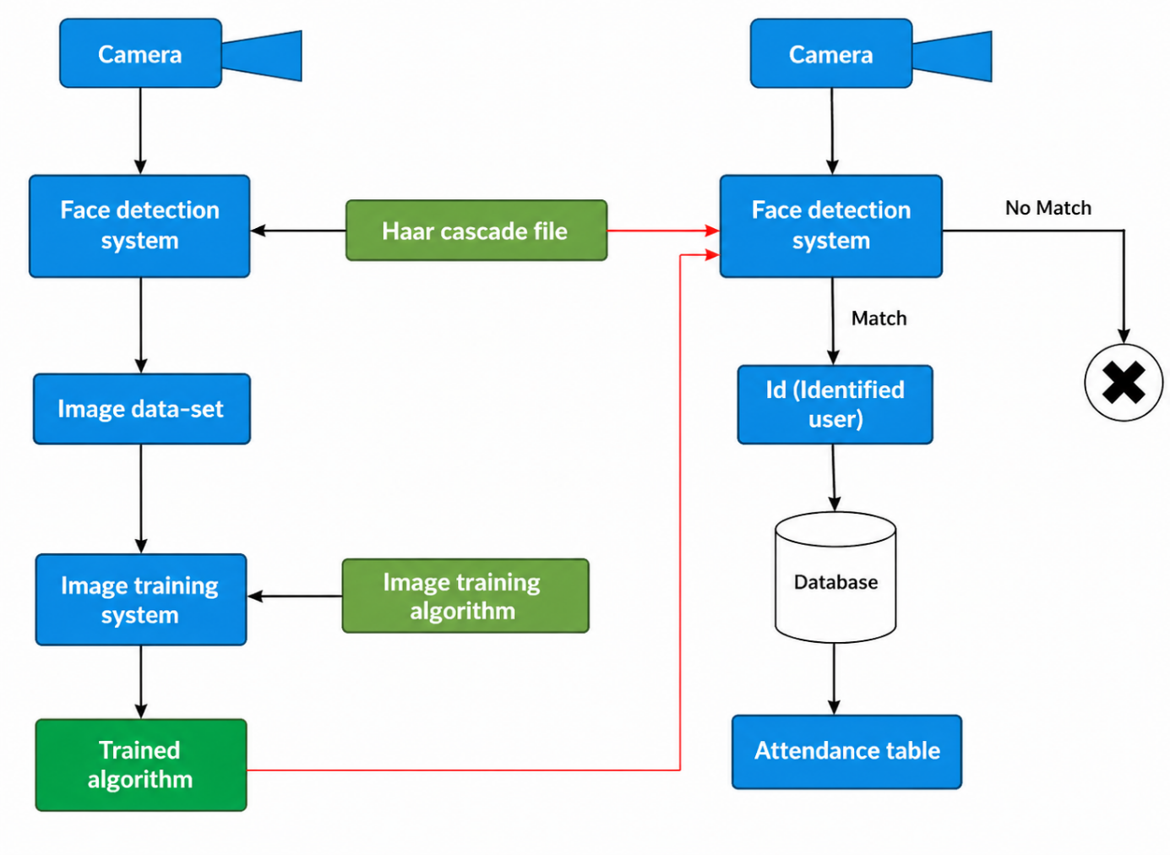

3.7 Advantages of Methodology
The proposed methodology offers several advantages:
- Automated Process: Eliminates manual attendance marking
- Contactless System: No physical interaction required
- High Accuracy: Reduces errors and improves reliability
- Prevents Proxy Attendance: Ensures authenticity
- Time Efficient: Saves time in large environments
- User-Friendly: Easy to use and implement
- Scalable: Can be extended to different applications
These advantages make the system suitable for modern institutions and organizations.
3.8 Limitations of Methodology
Despite its advantages, the system has certain limitations:
- Performance may be affected under poor lighting conditions
- Recognition accuracy may reduce with facial obstructions (mask, glasses)
- Requires a good quality camera for better results
- High computational requirements for large datasets
- Difficulty in handling crowded environments
These limitations can be addressed in future improvements using advanced technologies.
3.9 Summary
In conclusion, the methodology provides a clear and structured approach to developing a smart attendance system using computer vision. By integrating data collection, face detection, recognition, and automated attendance marking, the system achieves efficiency, accuracy, and reliability.
This methodology forms the foundation for implementation and demonstrates how modern technologies can be applied to solve real-world problems effectively.

Chapter 4:
System Design
The system design of the project “Smart Attendance Management System using Computer Vision” describes the overall architecture, components, and internal working of the system. It explains how different modules interact with each other to perform face detection, face recognition, and automatic attendance marking.
A well-defined system design is essential to ensure that all components work together efficiently and the system performs reliably in real-time conditions. This chapter provides a detailed explanation of system architecture, data flow, and functional modules.
4.1 System Architecture
The system architecture defines the structure and organization of the system. It represents how different components are connected and how data flows between them.
The proposed system consists of the following main components:
- Camera Module
The camera module acts as the input device of the system. It captures real-time video or images of individuals present in the environment. The quality and positioning of the camera play an important role in ensuring accurate face detection and recognition.
- Face Detection Module
This module processes the captured frames and identifies human faces. It uses algorithms such as the Haar Cascade Classifier to detect faces efficiently. The output of this module is a set of detected face regions.
- Once faces are detected, this module identifies individuals by comparing detected faces with stored data. It uses ArcFace-based face embeddings generated through InsightFace along with similarity matching logic. This module is responsible for determining the identity of each individual.
- Database Module
The database module stores all necessary data, including:
  - Registered user information
  - Facial image dataset
  - Attendance records (name, date, time)
The database ensures proper data management and allows easy retrieval of information when needed.
- User Interface (UI)
The user interface provides interaction between the user and the system. It displays outputs such as detected faces, recognized names, and attendance status. It may also allow users to register new individuals and view attendance records.

The interaction between these components ensures a smooth workflow from capturing input to storing attendance data. Each module performs a specific task, contributing to the overall functionality of the system.
4.2 Data Flow
The data flow describes how information moves through the system from input to output. It ensures that each step is executed in a logical sequence.
The data flow in the system follows these steps:
- Image Capture
The camera captures real-time video input and converts it into frames.
- Preprocessing
The captured frames may be converted into grayscale images to simplify processing and improve detection speed.
- Face Detection
The system scans each frame to detect faces using the Haar Cascade algorithm. Detected faces are highlighted and extracted.
- Feature Extraction
The detected face regions are processed to extract unique facial features.
- Face Recognition
The system compares extracted features with the stored dataset using the trained model. If a match is found, the identity of the individual is determined.
- Attendance Marking
Once the individual is recognized, attendance is automatically recorded with date and time.
- Data Storage
The attendance information is stored in a database or file system such as CSV or Excel.
- Output Display
The system displays the result on the user interface, showing recognized names and attendance status.
This structured data flow ensures that the system operates efficiently and provides real-time results.
4.3 System Modules
The updated web-based system is organized into the following practical modules:
Admin Authentication Module: Provides restricted access to registration, training, student records, and attendance reports.
Student Registration Module: Captures guided face samples, stores the student with a unique numeric ID and name, and collects multiple face angles for better recognition.
Face Training Module: Builds the recognition model from registered student face samples and ignores unregistered records.
Attendance Verification Module: Captures a live face, compares it with the trained model, and marks attendance only when the match is valid.
Duplicate Attendance Control Module: Prevents the same student from being marked present more than once on the same date.
Attendance Analytics Module: Calculates present days, total attendance days, and attendance percentage for each student.
To improve organization and maintainability, the system is divided into multiple functional modules. Each module performs a specific task and contributes to the overall system operation.

1. Registration Module
The registration module is responsible for enrolling new users into the system. It captures multiple images of each individual using a camera and stores them in the dataset. The registration screen guides the student to look straight, then left, right, up, and down so that the saved samples cover practical face poses.
Key functions:
- Capture facial images
- Assign labels (name/ID)
- Store images in dataset
This module ensures that sufficient data is available for training the recognition model.
2. Training Module
The training module processes the collected dataset and builds the recognition model. It extracts features from facial images and associates them with corresponding labels.
Key functions:
- Read dataset images
- Extract facial features
- Train the recognition model (e.g., ArcFace embedding model)
- Save trained model
The accuracy of the system largely depends on the quality of training.
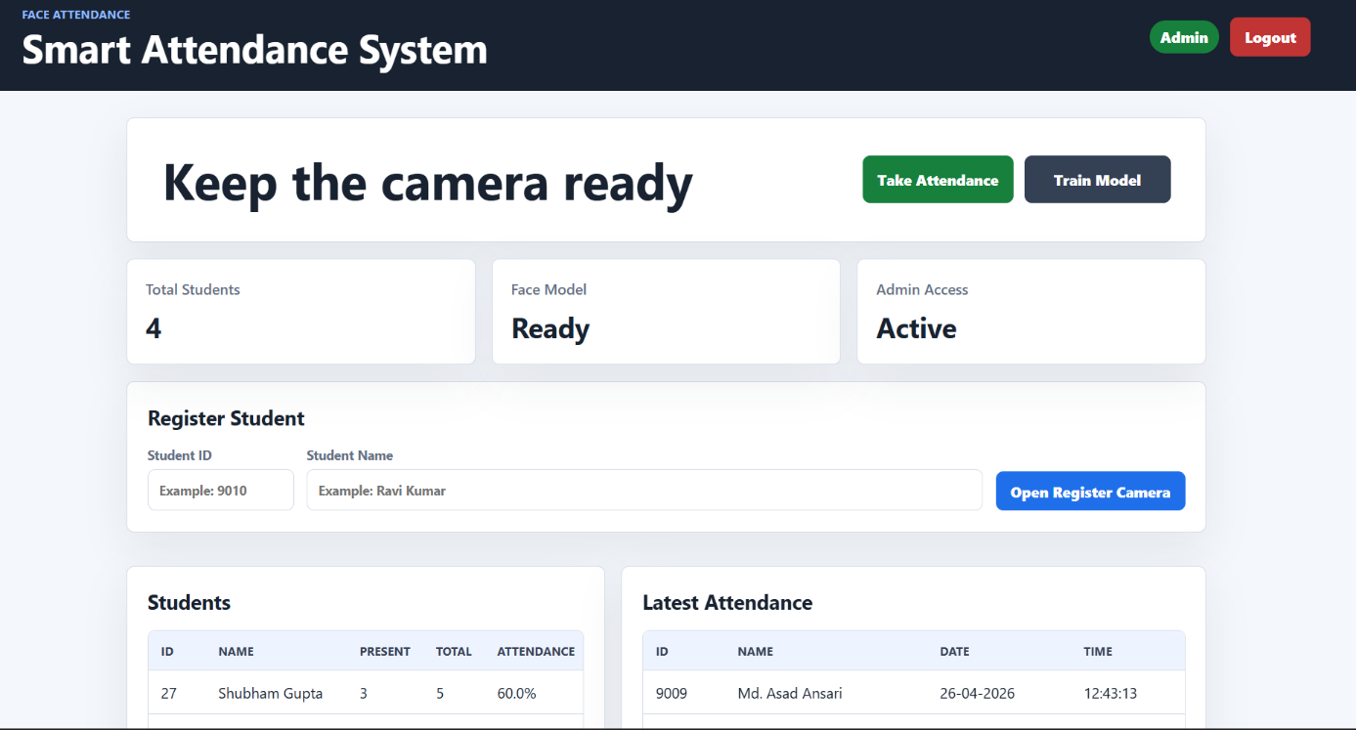
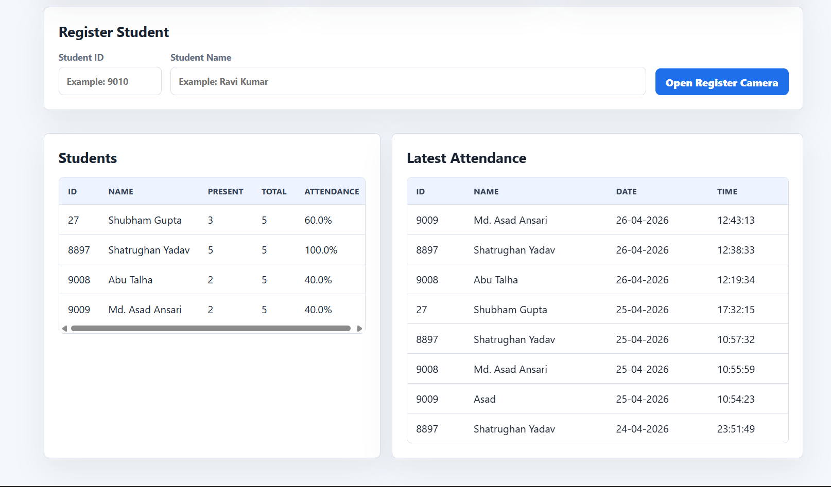

3. Recognition Module
The recognition module is responsible for identifying individuals in real-time. It takes input from the face detection module and compares it with the trained model.
Key functions:
- Receive detected faces
- Extract features
- Match with stored data
- Identify individual
This module plays a crucial role in ensuring accurate attendance marking.

4. Attendance Module
The attendance module records attendance once a face is recognized. It ensures that each individual’s attendance is marked only once per session.
Key functions:
- Record name, date, and time
- Avoid duplicate entries
- Store data in date-wise Excel files
This module ensures accurate and organized attendance management.
4.4 Flowchart
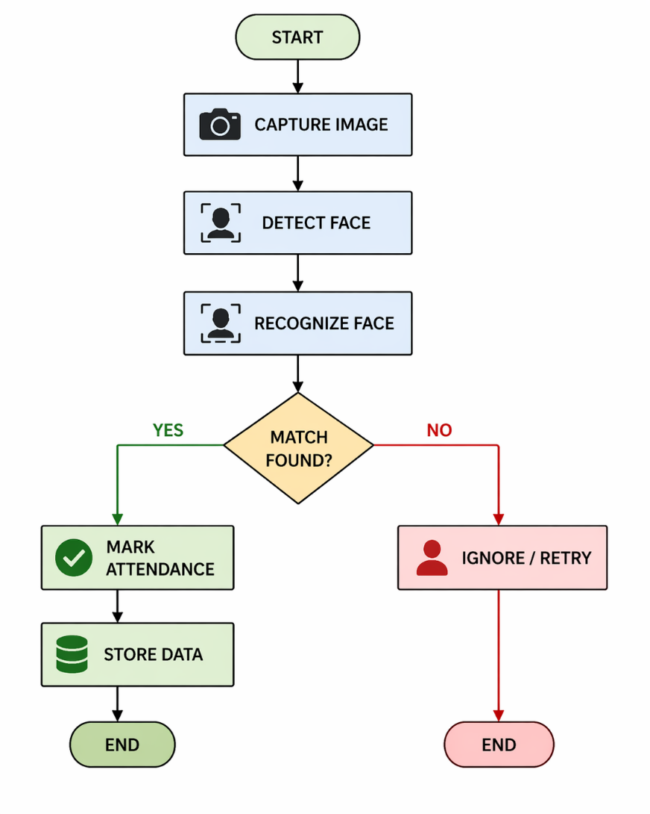
4.5 Database Design
The database plays a crucial role in the Smart Attendance Management System as it stores and manages all the necessary information related to users and attendance records. A well-structured database ensures efficient data storage, quick retrieval, and accurate record management.
The system maintains two primary types of data:
- User Data (Registration Information)
- Attendance Records
The database stores the following details:
- User ID: A unique identifier assigned to each individual
- Name: The name of the registered user
- Attendance Date: The date on which attendance is recorded
- Time: The exact time of attendance marking
In addition to these fields, the system may also store facial image data or encoded features used for recognition. These images are typically organized in folders or stored in a structured dataset.
The database can be implemented using different storage formats depending on system requirements:
- CSV (Comma-Separated Values):
A simple and lightweight method for storing attendance data. It is easy to implement and suitable for small-scale systems.
- Excel Sheets:
Useful for viewing and managing attendance records in a tabular format. It provides better readability and is commonly used in educational institutions.
- MySQL or Other Database Systems:
Suitable for large-scale applications. These systems provide better security, scalability, and efficient data management. They allow multiple users to access and update data simultaneously.

The database design ensures:
- Organized storage of attendance records
- Easy retrieval of data for analysis
- Prevention of duplicate entries
- Secure handling of user information
Overall, the database module is essential for maintaining reliable and accurate attendance records.
4.6 System Requirements
The successful implementation of the Smart Attendance Management System depends on both hardware and software requirements. These requirements ensure that the system runs smoothly and performs efficiently.
Hardware Requirements
- Computer/Laptop:
A system capable of running Python and processing real-time video input.
- Webcam or Camera:
Used to capture real-time images or video for face detection and recognition.
- Minimum 4GB RAM:
Required to handle image processing and ensure smooth execution of the system.
- Processor (Recommended):
A modern processor (Intel i3 or higher) for better performance.
- Storage:
Sufficient storage space to store datasets and attendance records.
Software Requirements
- Python:
The primary programming language used to develop the system due to its simplicity and strong library support.
- OpenCV Library:
Used for image processing, face detection, and video capture.
- NumPy:
Helps in numerical computations and handling image arrays.
- Pandas:
Used for managing attendance records and storing daily attendance data efficiently.
- IDE (VS Code / PyCharm):
Provides a development environment for writing, testing, and debugging code.
- Operating System:
Windows, Linux, or macOS can be used.
These requirements ensure that the system operates efficiently and provides accurate results in real-time.
4.7 Algorithm Used
The proposed system uses face detection and face recognition algorithms to identify individuals and mark attendance automatically. These algorithms form the core of the system and enable intelligent decision-making.
Algorithms Used in the System
- Haar Cascade Algorithm
The Haar Cascade algorithm is used for detecting faces in images. It is a machine learning-based approach that uses trained classifiers to identify facial features such as eyes, nose, and mouth. It is fast and efficient, making it suitable for real-time applications.
- ArcFace (InsightFace with ONNX Runtime)
ArcFace is used for face recognition. It converts each face into an embedding vector and compares the similarity of that vector with registered student embeddings. This approach provides stronger identity separation and better accuracy than basic texture-based methods.
Algorithm: Smart Attendance using Face Recognition
The complete working of the system can be explained through the following algorithm:
Step 1: Start the system
Step 2: Initialize the camera for real-time video capture
Step 3: Capture image/frame from the camera
Step 4: Prepare the captured image/frame for face analysis
(The frame is converted into a suitable format for detection and embedding extraction)
Step 5: Apply face detection using Haar Cascade classifier
Step 6: If a face is detected, extract the face region
(This isolates the region of interest for recognition)
Step 7: Apply face recognition using ArcFace embeddings
Step 8: Compare the detected face embedding with the stored registered-student embeddings
Step 9: If a valid match is found:
-> Mark attendance
-> Store name, ID, date, and time in the daily attendance file
-> Display attendance percentage and current status
Step 10: If a valid match is not found:
-> Ignore the face or retry detection
Step 11: Repeat the process for the next frame
(This ensures continuous real-time operation)
Step 12: Stop the system when required
4.8 Advantages of Algorithm
The algorithms used in the system provide several benefits:
- Fast and efficient face detection
- Accurate recognition of individuals
- Works in real-time environments
- Reduces manual effort
- Improves system reliability
4.9 Limitations of Algorithm
Despite its effectiveness, the algorithm has some limitations:
- Accuracy may decrease under poor lighting conditions
- Performance may be affected by facial obstructions (mask, glasses)
- Requires proper training dataset for better results
- Limited performance in highly crowded environments
4.10 System Design Considerations
While designing the system, several important factors are considered:
- Accuracy: Ensuring correct identification of individuals
- Speed: Real-time processing of video frames
- Scalability: Ability to handle multiple users
- Usability: Easy interaction through user interface
- Security: Protection of stored data
These considerations help in building a robust and reliable system.
4.11 Advantages of System Design
The proposed system design offers several benefits:
- Modular structure for easy development and maintenance
- Efficient data flow for real-time performance
- High accuracy using face recognition techniques
- Contactless operation ensuring safety and hygiene
- Easy integration with existing systems
4.12 Summary
In conclusion, the database design, system requirements, and algorithms together form the backbone of the Smart Attendance Management System. The database ensures proper data storage, the system requirements provide the necessary environment for execution, and the algorithms enable intelligent face detection and recognition.
These components work together to deliver a reliable, efficient, and automated attendance solution.
In conclusion, the system design provides a clear blueprint for implementing the Smart Attendance Management System. It explains how different components and modules work together to achieve automation, accuracy, and efficiency.
The modular architecture, structured data flow, and well-defined components ensure that the system is reliable, scalable, and suitable for real-world applications.

Chapter 5:
Implementation
The implementation of the project “Smart Attendance Management System using Computer Vision” involves developing a complete system that captures images, detects faces, recognizes individuals, and records attendance automatically. The system is implemented using Python along with various computer vision and data handling libraries.
This chapter explains how each module is developed and integrated to form a working system. It also includes code snippets and their explanations to provide a clear understanding of the implementation process.
5.1 Tools and Technologies Used
The updated implementation uses Python with Flask for the web application, OpenCV for face detection and image processing, InsightFace ArcFace for recognition, ONNX Runtime for inference, Pandas and OpenPyXL for Excel-based attendance storage, and HTML/CSS for the frontend interface.
A Windows batch launcher is also provided so that the project can be started through a simple click instead of manually running it from the development environment each time.
The system is developed using the following tools and technologies:
- Programming Language: Python
Python is used due to its simplicity, readability, and strong support for machine learning and computer vision.
- Libraries:
  - OpenCV: Used for image processing, face detection, and video capture
  - NumPy: Used for numerical operations and handling image arrays
  - Pandas: Used for managing attendance data and storing records
- IDE: VS Code / PyCharm
These environments are used for writing, debugging, and executing the code.
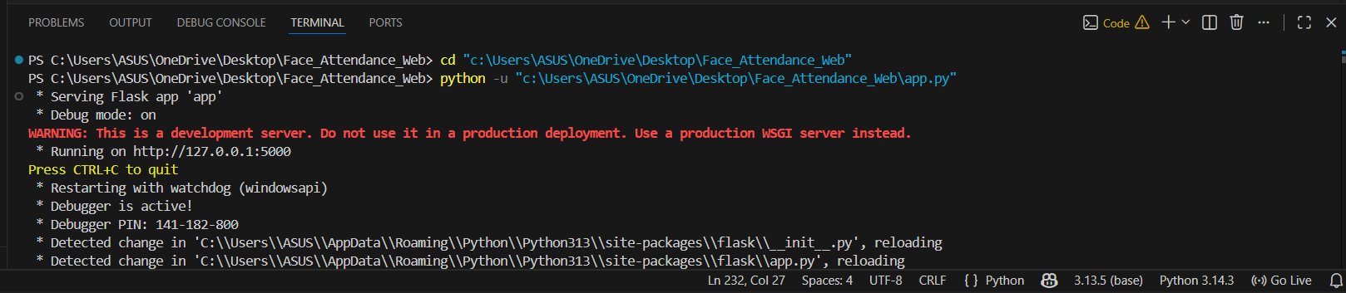
- Database: CSV / Excel File
Attendance data is stored in a structured format for easy access and management.
These technologies collectively enable efficient development and execution of the system.
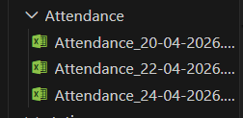
5.2 Key Modules Implementation
The implementation was enhanced with unique ID validation so that two students cannot share the same ID. Names can be repeated, but the ID remains the primary key for recognition and attendance records. The registration flow was also improved with guided prompts asking the student to look straight, left, right, up, and down during image capture.
The attendance logic now checks the current day's Excel file before saving a new record. If the student ID is already present in that file, the system shows the message with the student name and does not write another attendance entry.
The admin dashboard displays student records and attendance percentage only after login, while the public first page remains simple with attendance and admin login options.
The system is divided into multiple modules, each responsible for a specific task. These modules are implemented using Python and OpenCV.
1. Image Capture Module
This module is responsible for capturing real-time video using a webcam.
import cv2
cap = cv2.VideoCapture(0)
ret, frame = cap.read()
Explanation:
- cv2.VideoCapture(0) initializes the default camera (webcam)
- cap.read() captures a frame from the video stream
- frame stores the captured image
This module continuously captures frames, which are then processed for face detection and recognition.
2. Face Detection Module
Face detection is performed using the Haar Cascade classifier.
face_cascade = cv2.CascadeClassifier('haarcascade_frontalface_default.xml')
gray = cv2.cvtColor(frame, cv2.COLOR_BGR2GRAY)
faces = face_cascade.detectMultiScale(gray, 1.3, 5)
Explanation:
- The Haar Cascade model is loaded using Cascade Classifier
- The image is converted to grayscale to simplify processing
- detectMultiScale() detects faces in the image
- It returns coordinates of detected faces
This module identifies the location of faces in the frame and passes them to the recognition module.
3. Face Recognition Module
The system uses the ArcFace model through the InsightFace framework to recognize faces.
from insightface.app import FaceAnalysis
app = FaceAnalysis(name='buffalo_l', root='FaceModelStore')
app.prepare(ctx_id=0, det_size=(640, 640))
faces = app.get(frame)
- Explanation:
- FaceAnalysis initializes the ArcFace-based recognition pipeline
- prepare() loads the detection and recognition models
- app.get(frame) detects faces and generates embeddings
- The embedding is compared with the trained student embeddings
Similarity score indicates whether the detected face belongs to a registered student. This module improves identification reliability compared with basic recognizers.
4. Attendance Marking Module
This module records attendance with date and time and prevents duplicate marking on the same day.
import pandas as pd
from datetime import datetime
from pathlib import Path
today = datetime.now().strftime('%Y-%m-%d')
file_path = Path('Attendance') / f'Attendance_{today}.xlsx'
# Check existing IDs before writing a new row
data = {'Id': student_id, 'Name': name, 'Time': datetime.now().strftime('%H:%M:%S')}
df = pd.DataFrame([data])
df.to_excel(file_path, index=False)
Explanation:
- A date-wise attendance file is created or updated for the current day
- The system first checks whether the student ID is already present in that file
- Only new attendance records are written
- The saved record includes student ID, name, and time
This ensures that attendance records are stored in an organized, duplicate-free, and accessible format.
5.3 System Integration
All modules are combined to form a complete working system. Integration ensures smooth communication between different components.
The system operates as follows:
- The camera captures real-time video
- Frames are processed continuously
- Faces are detected in each frame
- Detected faces are recognized using the trained ArcFace model
- If a match is found, attendance is marked
- Data is stored in the database
This integration enables real-time automation of the attendance process without human intervention.
5.4 Output
The system produces the following outputs:
- Real-time face detection displayed on the screen
- Bounding boxes drawn around detected faces
- Recognized names displayed above faces
- Attendance automatically recorded in a daily Excel file
Example output:
- Face detected → Name displayed → Attendance marked
This output provides visual confirmation and ensures transparency in the system.

5.5 Advantages of Implementation
The implemented system offers several advantages:
- Fully Automated: No manual intervention required
- Contactless: No physical interaction needed
- Accurate: Reduces human errors and proxy attendance
- Fast Processing: Real-time performance
- Easy to Use: Simple interface and operation
- Low Cost: Uses basic hardware and open-source tools
These advantages make the system practical and suitable for real-world applications.
5.6 Challenges Faced During Implementation
During the development of the system, several challenges were encountered:
- Difficulty in detecting faces under poor lighting conditions
- Variations in facial expressions affecting recognition
- Managing real-time performance with limited hardware
- Ensuring accuracy with small datasets
These challenges were addressed by improving dataset quality and optimizing the code.
5.7 Testing and Validation
The system was tested using multiple users under different conditions. The following aspects were evaluated:
- Accuracy of face detection
- Recognition performance
- Speed of processing
- Correctness of attendance recording
The system showed satisfactory performance in controlled environments.

5.8 Summary
In conclusion, the implementation of the Smart Attendance Management System successfully integrates computer vision and machine learning techniques to automate attendance tracking. The system demonstrates efficient real-time performance, accurate recognition, and reliable data storage.
This implementation proves that modern technologies can be effectively used to solve real-world problems and improve operational efficiency.

Chapter 6:
Results and Discussion
The project titled “Smart Attendance Management System using Computer Vision” was successfully implemented and tested in a real-time environment. The system demonstrated the ability to capture video through a webcam, detect human faces, recognize individuals using trained models, and mark attendance automatically.
This chapter presents the results obtained from the system and provides a detailed analysis of its performance. It also discusses the effectiveness of the proposed system, along with its limitations and possible improvements.
6.1 Results
The updated system successfully provides a web-based attendance workflow in which students can be verified through the camera and attendance can be stored date-wise. After attendance is marked, the system displays the student name, ID, present days, total attendance days, and attendance percentage.
The system also prevents duplicate attendance on the same date. When the same student attempts to mark attendance again, the application displays a message such as: "Shatrughan Yadav (ID: 8897), your today's attendance is already marked."
The developed system produced satisfactory results during testing and evaluation. The following outcomes were observed:
- Real-Time Face Detection:
The system successfully detected human faces in real-time using a webcam. Faces were identified quickly and accurately within each frame, enabling continuous monitoring.
- Accurate Face Recognition:
The trained model was able to recognize individuals with good accuracy. The use of the ArcFace-based recognition pipeline improved identity matching and reduced the chance of weak matches being assigned to the wrong student under normal conditions.
- Automatic Attendance Recording:
Once a face was recognized, the system automatically recorded attendance without any manual intervention. This eliminated the need for traditional attendance methods.
- Data Storage:
Attendance records, including name, date, and time, were successfully stored in a CSV or Excel file. The stored data was well-organized and easy to access for future use.
- Real-Time Display:
The system displayed recognized names on the screen along with detected faces. This provided immediate visual confirmation of attendance marking.
- System Stability:
The system operated continuously without major interruptions, demonstrating stability and reliability during testing.
The system performed particularly well under normal lighting conditions and in controlled environments. It was able to identify individuals with a high level of accuracy when the dataset was properly trained using clear multi-angle samples.
6.2 Performance Analysis
The performance of the system was evaluated based on several key factors that influence its efficiency and accuracy.
1. Lighting Conditions
Lighting plays a crucial role in face detection and recognition. The system performed best under adequate lighting conditions where facial features were clearly visible. Poor lighting or shadows reduced detection accuracy and affected recognition performance.
2. Camera Quality
The quality of the camera significantly impacts system performance. Higher resolution cameras capture clearer images, leading to better detection and recognition. Low-quality cameras may produce blurred or noisy images, reducing accuracy.
3. Dataset Size and Quality
The accuracy of the system depends heavily on the training dataset. A larger dataset with diverse images improves the model’s ability to recognize faces under different conditions. Limited or poor-quality datasets can lead to incorrect predictions.
4. Face Angle and Expression
The system performs best when faces are directly facing the camera. Extreme angles, side views, or unusual facial expressions may reduce recognition accuracy. However, including varied images during training helps mitigate this issue.
5. Processing Speed
The system demonstrated real-time processing capability, with minimal delay in detecting and recognizing faces. This makes it suitable for practical applications in classrooms and offices.
6. System Efficiency
The system efficiently integrates detection, recognition, and attendance marking into a single workflow. It reduces manual effort and speeds up the attendance process significantly.
Overall, the system provides fast and reliable performance in controlled environments with proper setup.
6.3 Discussion
The results obtained from the system clearly indicate that the proposed solution is effective for automated attendance management. The integration of computer vision and machine learning technologies has significantly improved the efficiency and accuracy of attendance tracking.
One of the major advantages of the system is the elimination of manual processes. Traditional attendance methods require time and effort, whereas the proposed system automates the entire process. This not only saves time but also reduces human errors.
Another important benefit is the prevention of proxy attendance. Since the system identifies individuals based on unique facial features, it ensures that attendance is marked only for the actual person. This improves the reliability and authenticity of attendance records.
The system is also user-friendly and easy to deploy. It requires minimal hardware and can be implemented using a standard computer and webcam. This makes it cost-effective and accessible for educational institutions and organizations.
However, some challenges were observed during testing:
- Low Light Conditions:
The system’s accuracy decreases when lighting conditions are poor or inconsistent.
- Face Orientation Issues:
Recognition performance is affected when faces are not properly aligned with the camera.
- Crowded Environments:
The system may face difficulty in detecting and recognizing multiple faces simultaneously in crowded areas.
- Occlusion Problems:
Accessories such as masks, glasses, or hats can interfere with face recognition.
Despite these challenges, the system demonstrates strong potential for real-world applications. Most of these limitations can be addressed by improving the dataset, using better cameras, and applying advanced algorithms.
6.4 Comparative Analysis
When compared with traditional attendance systems, the proposed system shows significant improvements:
- Manual System vs Proposed System:
The manual system is slow and error-prone, while the proposed system is fast and automated.
- Biometric System vs Proposed System:
Biometric systems require physical contact, whereas the proposed system is contactless and more hygienic.
- RFID System vs Proposed System:
RFID systems depend on external devices, while the proposed system only requires a camera.
This comparison highlights the advantages of using computer vision for attendance management.

6.5 Practical Applications
The system can be applied in various real-world scenarios:
- Educational institutions for student attendance
- Offices for employee monitoring
- Training centers and workshops
- Secure areas requiring identity verification
Its flexibility and scalability make it suitable for different environments.
6.6 Future Improvements Based on Results
Based on the observed results, the system can be further improved by:
Adding monthly and semester-wise attendance reports with export options.
Integrating a centralized database for multi-class or multi-department deployment.
Adding a stronger deep-learning face recognition model for better accuracy in low light and crowded environments.
- Using deep learning models for higher accuracy
- Integrating cloud storage for centralized data management
- Enhancing performance in low-light conditions
- Improving recognition in crowded environments
- Adding mobile or web-based interfaces
These improvements can make the system more robust and versatile.
6.7 Summary
In conclusion, the results and analysis demonstrate that the Smart Attendance Management System using Computer Vision is an efficient and reliable solution for attendance tracking. The system successfully automates attendance marking, reduces errors, and improves overall productivity.
Although certain limitations exist, the system provides a strong foundation for further development and real-world implementation. It highlights the practical application of artificial intelligence and computer vision in solving everyday problems.

Chapter 7:
Conclusion and Future Scope
7.1 Conclusion
The updated Smart Attendance Management System improves the earlier implementation by adding a practical web interface, admin-controlled registration, guided multi-angle face capture, ArcFace-based recognition, unique student ID management, daily attendance tracking, attendance percentage calculation, and duplicate attendance prevention. These additions make the project more suitable for real classroom attendance management.
The project titled “Smart Attendance Management System using Computer Vision” has been successfully designed, developed, and implemented. The system provides an automated, efficient, and contactless solution for attendance management by utilizing modern technologies such as computer vision and machine learning.
Traditional attendance systems, including manual registers and ID-based methods, suffer from various limitations such as time consumption, human errors, and the possibility of proxy attendance. This project effectively overcomes these challenges by introducing a smart system that automates the entire attendance process. By using facial recognition technology, the system ensures that attendance is marked only for the actual individual, thereby improving authenticity and reliability.
The system is capable of capturing real-time video input, detecting faces accurately, and recognizing individuals using trained models. Once a person is identified, attendance is automatically recorded with details such as name, date, and time. This eliminates the need for manual intervention and ensures that records are maintained in an organized and error-free manner.
One of the key strengths of the system is its contactless nature. Unlike biometric systems that require physical interaction, this system uses facial recognition, making it more hygienic and convenient. This feature is especially beneficial in environments where minimizing physical contact is important.
The project also demonstrates the practical application of computer vision in solving real-world problems. It highlights how advanced technologies can be used to improve efficiency, accuracy, and productivity in everyday tasks such as attendance management. The integration of OpenCV, Flask, InsightFace ArcFace, and ONNX Runtime enables the system to perform efficiently in real-time conditions.
In addition, the system is user-friendly and cost-effective. It requires only basic hardware such as a computer and a webcam, making it accessible for educational institutions and small organizations. The use of open-source tools further reduces implementation costs.
The results obtained from the system indicate that it performs well under normal conditions, providing accurate face detection and recognition. The automated attendance recording system ensures reliable data storage and easy retrieval of records.
In conclusion, the Smart Attendance Management System using Computer Vision is a successful implementation of an intelligent attendance solution. It improves efficiency, reduces errors, enhances security, and provides a modern alternative to traditional attendance methods. The project serves as a strong foundation for further research and development in the field of computer vision and artificial intelligence.
7.2 Future Scope
Although the proposed system performs effectively, there are several opportunities for further improvement and enhancement. Future developments can make the system more advanced, scalable, and suitable for large-scale real-world applications.
One of the major improvements can be the integration with cloud-based databases. Currently, attendance data is stored locally in CSV or Excel files. By using cloud storage, data can be accessed remotely, managed centrally, and shared across multiple locations. This would be particularly useful for large institutions and organizations.
Another important enhancement can be liveness detection and further optimization of the ArcFace pipeline. While the current system already uses a deep face recognition model, future versions can improve spoof resistance, speed, and robustness under low light or crowded conditions.
The system can also be extended by developing a mobile or web-based application. This would allow administrators to monitor attendance remotely, generate reports, and manage user data from anywhere. Mobile integration would increase usability and accessibility.
Handling crowded environments is another area for improvement. The current system may face challenges when multiple faces are present simultaneously. Advanced algorithms and optimized processing techniques can be implemented to improve performance in such situations.
Improving performance under low lighting conditions is also an important enhancement. Techniques such as image enhancement, infrared cameras, or advanced preprocessing methods can be used to ensure consistent accuracy in different lighting environments.
The system can further be integrated with security and access control systems. For example, facial recognition can be used not only for attendance but also for controlling entry into restricted areas. This would increase the functionality and usefulness of the system.
Additional features that can be considered include:
- Real-time notifications and alerts
- Automated report generation
- Integration with academic or HR management systems
- Mask detection and recognition enhancements
- Multi-user and multi-location support
These improvements would make the system more robust, intelligent, and adaptable to different use cases.
In summary, the future scope of this project is vast. With continuous advancements in artificial intelligence and computer vision, the system can be further developed into a comprehensive and highly efficient attendance management solution. These enhancements will enable the system to meet the growing demands of modern institutions and organizations.

REFERENCES
- Richard Szeliski, Comput
- er Vision: Algorithms and Applications, Springer, 2010.
- Paul Viola and Michael Jones, “Rapid Object Detection using a Boosted Cascade of Simple Features,” IEEE Conference, 2001.
- OpenCV Documentation, https://opencv.org
- NumPy Documentation, https://numpy.org
- Pandas Documentation, https://pandas.pydata.org
- ArcFace / InsightFace documentation and research papers on deep face recognition
- Research papers on Computer Vision and Face Recognition, IEEE Xplore

APPENDIX
Appendix A: Sample Code
import cv2
import numpy as np
face_cascade = cv2.CascadeClassifier('haarcascade_frontalface_default.xml')
cap = cv2.VideoCapture(0)
while True:
ret, frame = cap.read()
gray = cv2.cvtColor(frame, cv2.COLOR_BGR2GRAY)
faces = face_cascade.detectMultiScale(gray, 1.3, 5)
for (x, y, w, h) in faces:
cv2.rectangle(frame, (x,y), (x+w,y+h), (255,0,0), 2)
cv2.imshow('Face Detection', frame)
if cv2.waitKey(1) == 27:
break
cap.release()
cv2.destroyAllWindows()
Appendix B: Sample Output
- Face detected on screen
- Name displayed on recognized face
- Attendance stored in a daily Excel file with date and time
Appendix C: Dataset Details
- Images captured using webcam
- Multiple images per person
- Stored as labeled images using unique student IDs and guided face angles

